Introducing on Kickstarter.com - HoofStep®’s innovation to monitor your horse’s welfare

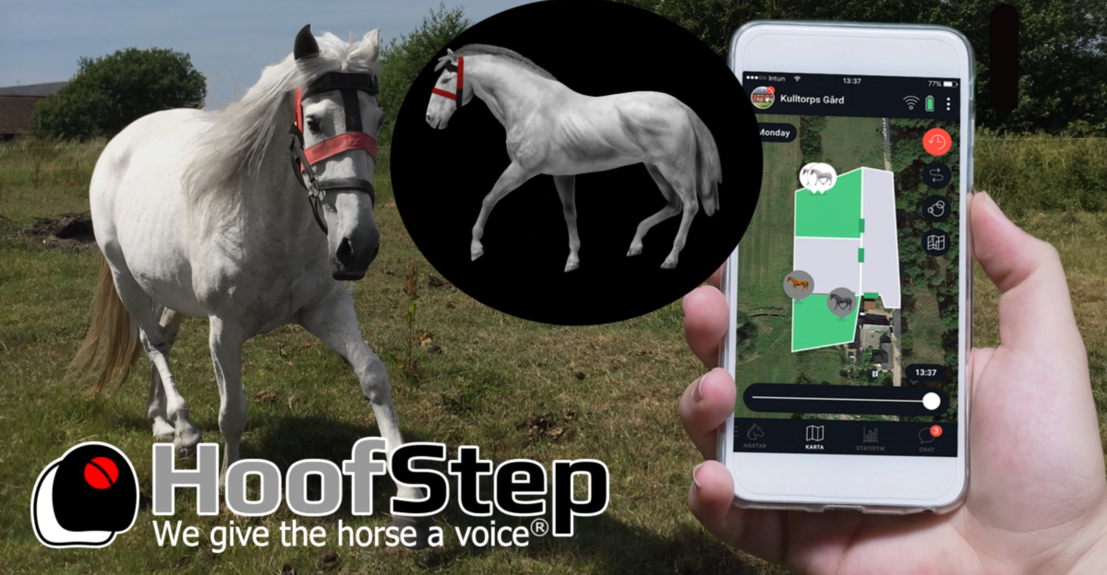

The app - your horse in your pocket!

The app where you see your own horse in the form of a digital lookalike that reflects your horse's ongoing behaviour is here! See where your horse is, how and where it moved during the day, see statistics and share information with horse friends. Use the library of emojis for the stable and unique emojis for your own horse's different behaviours. If something changes that can threaten the horse's well-being or health, a direct alarm is sent!

HoofStep® has developed a sensor that is attached to the horse to be able to follow its movements and activity via the smartphone or computer.
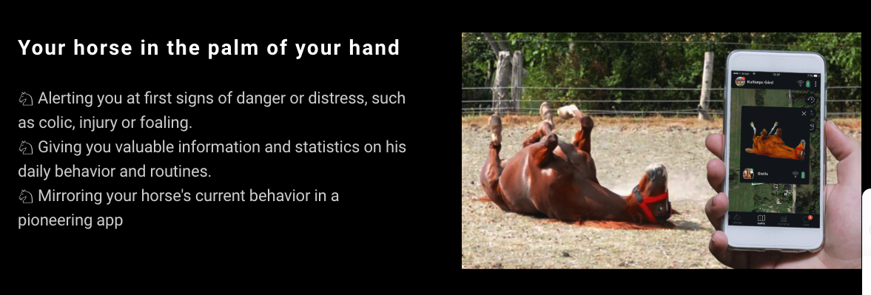

Put the horse at the center of your attention!
The product measures activity, which is broken down into different behaviours and combinations that describe, for example, colic behaviour or stress. Each horse has unique behavioural patterns, in combination with these and general behaviour for different conditions, such as colic, the HoofStep® AI model can identify if anything deviates from normal.

Monitoring around the clock, no matter where you are and situation!
The product can be worn around the clock, without disturbing, and in all situations; in the box during the night, in the garden or paddock, during training, in transport or in a guest stall on competition. If you have a mare, you will get an indication of when it get closer to foaling. When the foal is born you can follow both the mare's and the foal's first critical days. E.g. that the mare does not develop colic, that the foal eats and rests as it should and becomes increasingly active.

Many times you wanted to be there when it happened! The horse got cast in the stall, a serious injury in the pasture, the horse who for some reason became stressed in the pasture or during transportation. Also situations when one suspects that something is not right. Perhaps a subtle emerging colic attack, a horse that seems somewhat unwilling to work or just that "something is wrong". Often when faced with the facts and calling the vet, there are actual deviations already long before. Quickly capturing these through objective measurement and interpretation via AI is the foundation of HoofStep®'s solution. With faster measures, the suffering decreases and the prognosis improves.
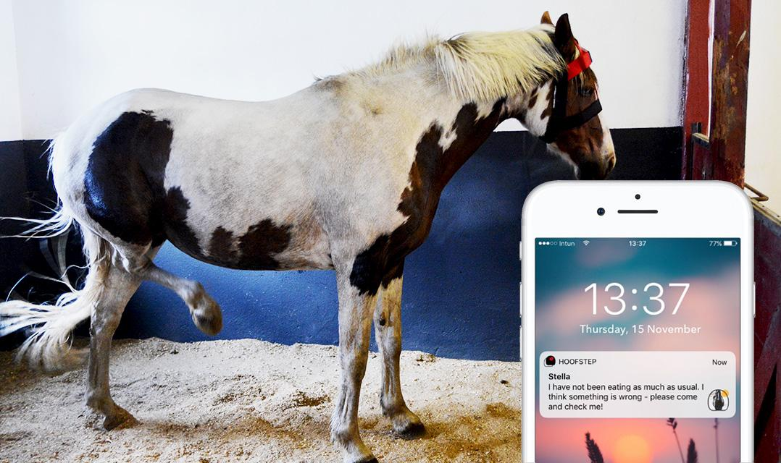

A greater scientific purpose
HoofStep® not only gives the individual horse owner a complementary tool for increased horse well-being, but at least equally important is that HoofStep® collects empirical data. The world's largest database for horse behaviour. Today, there is a lack of sufficient statistically secure data where one can draw conclusions that favor horses in general.

There are limited studies in veterinary medicine and insurance companies in turn compile data on the number of cases that come in. HoofStep® takes the step further, ie collects behaviour data from the horse in its entire context, before it arrives at the clinic and becomes part of the insurance company's statistics. The horse's behaviour is captured for a long time. By also knowing how it is installed, a better informed picture is obtained about what plays on the horse's well-being. All in all, this causes the cause of poorer health, illness or injury to the horse.

Interesting conclusions can also be drawn in relation to different characteristics of horses such as breed and age. Then you can get answers to exciting questions like: Is there any breed that significantly stresses to a greater extent than the others?

In addition to projects within, among other things, Ridsportens Innovations and clinics, the great value of contribution from each horse owner is by connecting their horse. This data is extremely valuable for future research. By allowing researchers to access the data, their insights will benefit all horses in general. Horse owners thereby receive better support from information based on a statistical foundation.

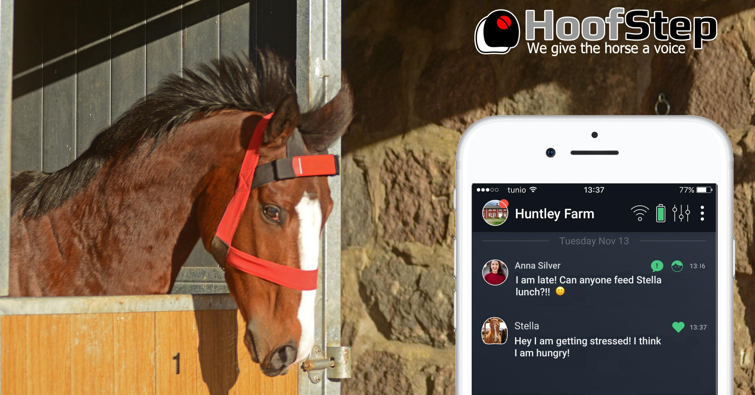

Product launch
In March, the HoofStep® product is launched on the market via Kickstarter.com. This after 3 years of development and testing together with veterinarians and many beta users. The first delivery goes to the customers who are on the waiting list and to those who are quick to order. If you have no horse to connect, you can use the app for free in support of your horse-life. If you are a playful person, you can create simulated digital lookalike horses and place them on your farm.

Visit our Kickstarter site:
https://www.kickstarter.com/projects/hoofstepcom/hoofstep-we-give-the-horse-a-voice/description

Visit our website www.hoofstep.com to join our messenger, so you stay up-to-date on the launch and get the opportunity to take part in favorable launch offers.

